Activity Experience of First-Year Students

Vitalyi N. Ivanov
Saint Petersburg State University, Saint Petersburg, Russia
ORCID: https://orcid.org/0000-0002-0777-1111, e-mail: ivanov@yandex.ru

Vladimir N. Petrov
Moscow State University of Psychology & Education, Moscow, Russia
ORCID: https://orcid.org/0000-0002-0777-1122, e-mail: petrov@yandex.ru
Summary: 150-200 words, Times New Roman, 12 pt. Single interval. Abstract text shall not be divided into paragraphs.
Keywords: up to 8 key words – activity-related experience, quality of motivation, self-determination theory, intrinsic motivation, extrinsic motivation, academic motivation.
Funding. The reported study was funded by Russian Foundation for Basic Research (RFBR), project number 20-01-00001
Acknowledgements. The authors are grateful for assistance in data collection Ivanov T.Yu.
For citation: Ivanov V.N., Petrov V.N. Features of Child Development in the Digital Sphere // Digital Humanities and Technology in Education (DHTE 20212): Collection of Articles of the III All-Russian Scientific and Practical Conference with International Participation. November 17–18, 2022 / V.V. Rubtsov, M.G. Sorokova, N.P. Radchikova (Eds). Moscow: Publishing house MSUPE, 2022. _–_ p.
Introduction
Document margins shall be put with values: ▪ Left margin: 2 cm, right: 2 cm; upper/lower: 2 cm ▪ First line indent: 1,25 cm. No hyphenation (including automatic hyphenation) is used in the text.
It is not recommended to emphasize big text fragments with italic/bold. No more than 5-7% of the text can be emphasized. Footnotes in the text are created automatically in MS Word.
Typing last names in the text shall be after initials. No space is between initials. But a space shall be between initials and last name. Decimal fractions shall be typed with a comma. (0,25 instead of 0.25). Such « » quotation marks shall be used. If other quoted words occur within words in quotation marks, then « » are used as external and „ “ as internal quotation marks. Quotation marks and brackets are not separated with spaces from the words inside them.
Tables shall be created in MS Word (Table > add table) or MS Excel. Manually typed tables (by means of many spaces without allocation to cells) are not acceptable. Tables shall contain no more than ten columns and have an informative heading. Abbreviated words in tables are inacceptable. Tables are numbered in Arabian figures consequently as there are mentioned in the text. In table headings the word “Table” and its corresponding number are aligned right. No point at the end. Table name shall be typed in the next line after number of the table. No point at the table. Name is typed in bold and center aligned. Example:
Table 4
Descriptive statistics for all measured variables: mean ± standard deviation,
median [lower quartile; upper quartile], minimum, and maximum (N=406)
Questionnaires and scales | M ± SD | Me  [LQ; UQ] | Min | Max
Activity-Related Experiences Assessment technique (AREA)
Effort | 12,8 ± 3,4 | 13 [11; 15] | 3 | 18
Pleasure | 11,5 ± 3,9 | 12 [9; 14] | 3 | 18
Meaning | 14,0 ± 3,7 | 15 [12; 17] | 3 | 18
Void | 7,7 ± 3,6 | 7 [5; 10] | 3 | 18

Pictures and drawings. All pictures shall be compulsory included into the text of the article in respective places. The picture shall be understandable, clear, inscriptions shall correspond to text content. If scans are used, scanned pictures shall be made in maximal scanning dimension. Photos are submitted in undamaged condition. Minimal format of the photos is 800x600 px (size – no less than 1 Mb). Authors are responsible for quality of pictures and diagrams. Title shall be typed below the picture. Abbreviation “Fig.” and its corresponding number are typed in italics. Title of the picture is not emphasized. Example: Fig.1. Semantic area of role positions dynamics… If there is a single picture in publication, it has number and its layout is the same. All pictures shall be referenced in the text. All inscriptions inside the picture shall be capitalized. If a picture is referenced, it shall be abbreviated as “fig.” Example: Average response time in younger group is more than in elder (fig. 1). All legends to illustrations (diagrams, graphs etc.) are given under the picture as follows. Example:

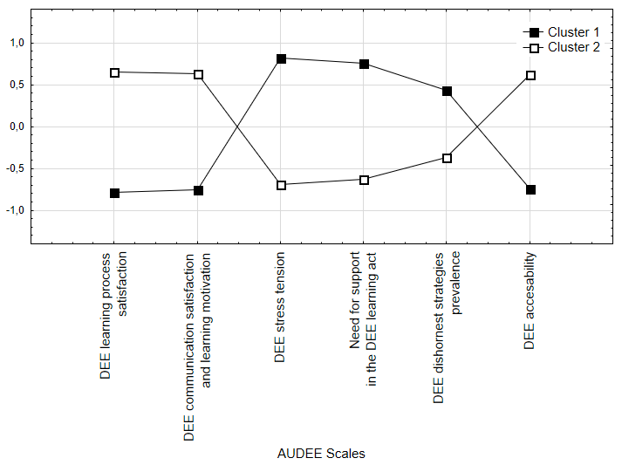
Pict. 1. k-means cluster analysis results

Any materials, theory, statement, study published earlier shall be compulsory followed by a reference to a source of literature.
For literature reference, after-text references are used (they are specified in references). All sources included in references list shall be referenced in square brackets in text of the article. Reference to literature source is typed after name or citation. Reference to source is a number of the source in references only and is typed in square brackets. Example: [5]. If several sources are referenced, number of sources are typed in square brackets with a semicolon between the sources. The sources are enumerated in ascending order. Example: [3;10]. In citation pages in brackets are typed after number of the source with a comma. Example: [4, p.12].

References
1. Dubrovina I.V. Idei L.S. Vygotskogo o soderzhanii detskoi prakticheskoi psikhologii [Ideas L.S. Vygotsky on the content of children’s practical psychology]. Psikhologo-pedagogicheskie issledovaniya = Psychological-Educational Studies, 2013, no. 3. Available at: http://psyedu.ru/ journal/2013/3/3432.phtml (Accessed 18.11.2013). (In Russ.).
2. Zabrodin Yu.M., Metelkova E.I., Rubtsov V.V. Conception and Organizational and Structural Models of Psychological Service in Education. Psikhologo-pedagogicheskie issledovaniya = Psychological-Educational Studies, 2016. Vol. 8, no. 3, pp. 1–15. DOI:10.17759/psyedu.2016080301. (In Russ.).
3. Blair C. How similar are fluid cognition and general intelligence? A developmental neuroscience perspective on fluid cognition as an aspect of human cognitive ability. Behavioral Brain Science, 2006. Vol. 29, no. 2, pp. 109–125. DOI:10.1017/S01405 25X06009034

Information about the authors
Vitalyi N. Ivanov, PhD in Psychology, Leading Research Associate, Associate Professor, Chair of Psychology, Saint Petersburg State University, Saint Petersburg, Russia, ORCID: https://orcid.org/0000-0002-0777-1111, e-mail: ivanov@yandex.ru
Vladimir N. Petrov, PhD in Psychology, Leading ResearchAssociate, CenterofApplied Psychological Studies, Moscow State University of Psychology & Education, Moscow, Russia, ORCID: https://orcid.org/0000-0002-0777-1122, e-mail: petrov@yandex.ru

